PROJECT DESIGN PHASE
Incident Lifecycle Automation in ServiceNow
Date | 06 September 2026 | Team ID | ________
Project Name | Incident Lifecycle Automation in ServiceNow | Maximum Marks | 2 Marks
Problem – Solution Fit
Organizations often receive IT incidents through emails, phone calls, or informal communication. This can cause poor tracking, inconsistent classification, delayed escalation, SLA breaches, and limited visibility into resolution progress. The proposed solution uses ServiceNow Incident Management to standardize and automate the incident lifecycle from creation through resolution and knowledge reuse.
Purpose
• Enable Service Desk agents to create and classify incidents in a structured way.
• Integrate Knowledge Management to help agents find faster solutions.
• Route and reassign incidents to the appropriate support groups.
• Enable Level 2 technicians to investigate, update, and resolve incidents.
• Create emergency change requests directly from incidents when required.
• Create child incidents to track recurring or related issues.
• Generate knowledge articles from resolved incidents for future reuse.
• Improve SLA compliance, tracking, reporting, and service visibility.
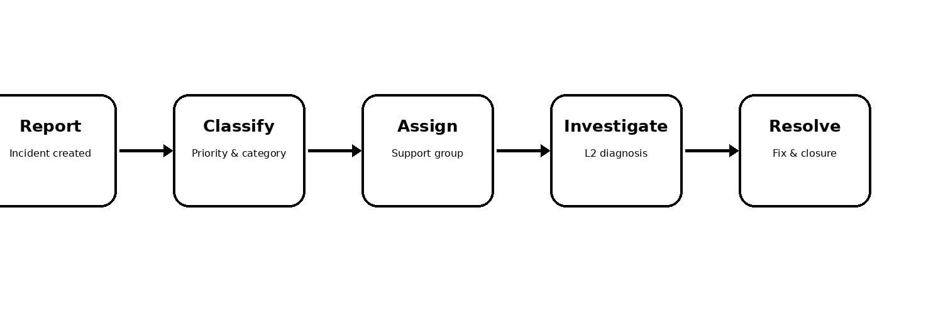
Figure 1. Standardized ServiceNow incident lifecycle

INCIDENT LIFECYCLE AUTOMATION – SOLUTION FIT
Solution Workflow
1. Incident Creation: Service Desk receives the issue and records the incident with relevant user, service, description, and impact details.
2. Classification & Prioritization: The incident is categorized and assigned a priority so urgent issues receive appropriate attention.
3. Assignment: The incident is routed or reassigned to the correct support group for action.
4. L2 Investigation & Resolution: Level 2 technicians investigate the issue, document work notes, apply the fix, and update the incident state.
5. Change & Child Incident Handling: Emergency changes can be initiated from an incident, while child incidents can be created for related or recurring issues.
6. Knowledge Reuse & Closure: Resolved incidents can provide input for knowledge articles, while closure ensures the final resolution and SLA information are recorded.
Expected Benefits
• Centralized incident tracking and complete resolution history.
• Faster resolution through knowledge search and reuse.
• Better assignment, escalation, and collaboration between support levels.
• Improved SLA monitoring and reduced risk of missed targets.
• Better visibility through incident queues, status updates, and reporting.
• Reusable knowledge captured from successfully resolved incidents.
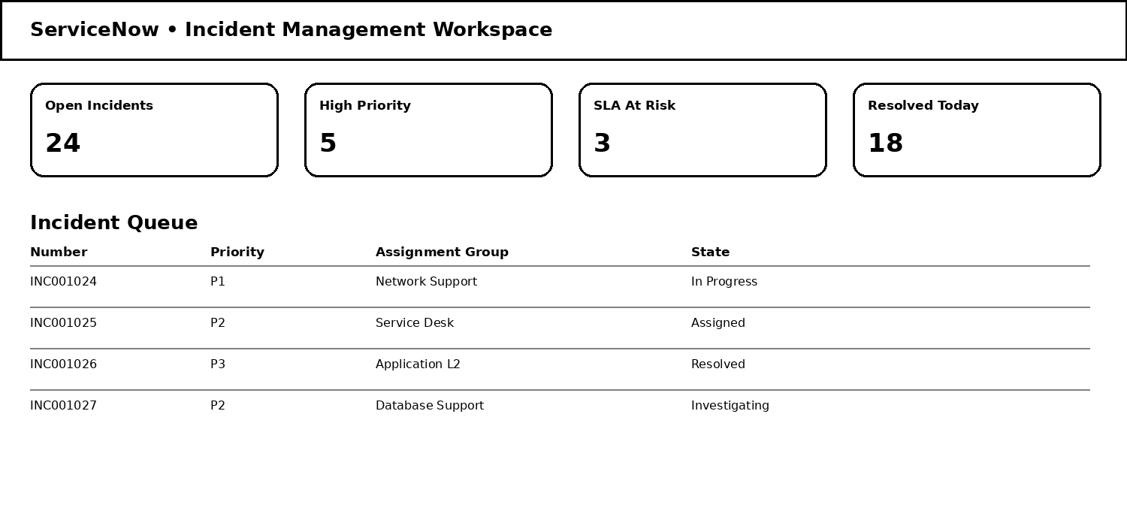
Figure 2. Illustrative ServiceNow Incident Management workspace
Problem–Solution Fit Summary
The problem is the lack of a consistent, visible, and controlled incident-handling process. The solution fits this need by using ServiceNow to provide a structured workflow for incident creation, classification, assignment, investigation, resolution, change handling, child-incident tracking, and knowledge reuse.
Reference
ServiceNow Incident Management – project concept and workflow prepared from the provided Incident Lifecycle Automation requirements.

